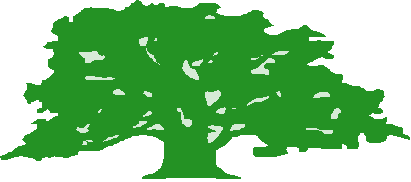Derwen Foundation School Ysgol Sefydledig Derwen
Main Road Prif Ffordd
Higher Kinnerton Higher Kinnerton
Flintshire Sir y Fflint
CH4 9AJ CH4 9AJ
‘Developing Potential Through
Educational Excellence’
Tel: 01244 660291 Ffon: 01244 660291
Fax: 01244 661446 Fax: 01244 661446
kimail@hwbcymru.net kimail@hwbcymru.net
Mr R K Jones, B Ed. (Hons) N.P.Q.H
Pennaeth/Headteacher
31/03/20

Dear Parent/Guardian,

This letter contains further information for you and your child regarding distance learning. As you are aware classteachers have been setting work for your child under the Distance Learning tab on the school website. We have, as a school, been investigating other options for the setting of work during these unprecedented and difficult times.

We have been exploring the use of Google Classroom as a tool for staff to set work for pupils. This platform will enable your child to complete work and submit it back to their classteacher for feedback.

As before, work will be uploaded by 8pm on a Sunday evening ready for the following week. Ysgol Derwen staff are responsible for running and managing the Hope Hub every Monday so staff will be periodically logging on to Google Classroom Tuesday to Friday between the hours of 9.30am and 3pm to look at work which has been uploaded by pupils and, where appropriate, give relevant feedback.

As this is a completely new way of working for staff I ask you to be patient with us as we are developing our skills with this new platform. Please be considerate if at any point, work for your child’s class does not appear. There will be a good reason for this.

Should you require any further clarification, please email the school kimail@hwbcymru.net and we will endeavour to address any issues as soon as possible.

It is also important pupils remain mindful of online safety and the appropriate use of technology whilst they are at home and we appreciate your support in discussing this with your child.

How to access Google Classroom with your child.
- Your child will need to log on to Hwb using their personal details.
- Once logged on click on the menu tab and look for the Google For Education icon.
- You will need to type in your child’s Hwb email to verify the account.
- Click student option.
- You will then see a classroom which is your child’s Google Classroom.
- Once you enter this classroom you will find the work for the week.

It may take a while for you and your child to navigate this platform and become familiar with how its tools work so to start with we will also still upload the work onto the school website should you find this an easier option to use.

Please note that staff are being expected to work over the Easter holiday at the Hope Hub caring for key worker children however it is still a holiday for your child and as a result no work will be set during this period. You can expect to find your child’s next set of work and Google Classroom up and running on Sunday 19th April, 2020.

Thank you for your continued support.

Richard Jones
Headteacher

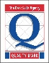
Cyfeirer pob gohebiaeth i’r Prifathro
Please address all communications to the Headteacher

