Derwen News – March 9th 2022
Covid Update
Covid is still impacting Ysgol Derwen with a number of pupils across the school currently self-isolating. We currently have 15 pupils and one member of staff absent from school with Covid - Reception (6), Year 1 (2), Year 2 (1), Year 3 (1), Year 4 (2), Year 5 (2) Year 6 (1)
Please continue to be vigilant and undertake a test if anyone in the family has been in close contact with a positive case or if they have any symptoms. If you are struggling to get a LFT we have some in school you can use.

A brighter future
We are all hoping for better days ahead after two years of Covid disruption. As restrictions start to ease and schools start to return to some sort of normality, I will be sending a couple of questionnaires out over the coming weeks to help me plan for a brighter future for Ysgol Derwen.
I will be seeking your views on the school, things we can improve on, and also what you believe makes our school unique and special.
With a New Curriculum for Wales being introduced in September 2022, it provides an ideal opportunity for everyone associated with Ysgol Derwen to have a say in the direction the school takes in the coming years.

Parent Governor Vacancy
We currently have a vacancy for a parent governor at Ysgol Derwen . Parent governors are elected as representatives of the interests of parents of pupils currently attending the school. A parent governor can continue to serve until the end of their four-year term of office, even if their child leaves the school during the period.
Nominations are invited from parents/guardians and applications can be made by requesting an application form from the school office.
If you wish to nominate any parent, or nominate yourself, you should complete and submit the form before the deadline of 3.20pm on Friday 18th March 2022.
If there are more nominations than vacancies then a ballot will be held. More details will be shared on whether a ballot is needed.

Ukraine Appeal
Thank you so much to everyone who supported our appeal to help refugees from the war in Ukraine. We have been overwhelmed with your generosity. The sorting warehouses were inundated with donations from across the region so had to stop accepting donations during the day on Friday. Some of your donations made it onto the convoy which left for Poland at the start of this week and the remaining items will be delivered to the warehouse in time for the next convoy.

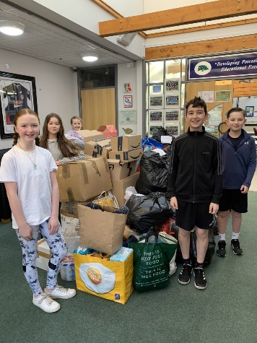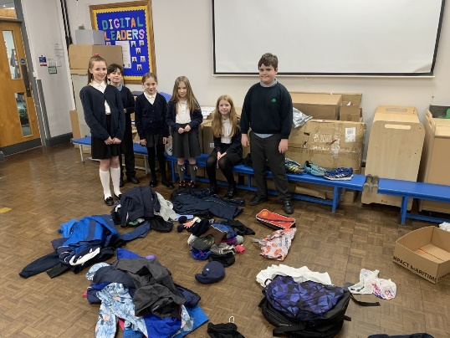
Year 6 pupils helping organise the donations.

Wellbeing Fortnight
We are hoping to hold a wellbeing fortnight at the end of May and incorporating sports day during this period. We would like to offer a range of experiences to our pupils and parents during this event and I would love to have your help and support in organising a fortnight of activities. If you know of any sports coaches etc who would be willing to support our Wellbeing Fortnight by offering a taster session to a class/groups/whole school (preferably free of charge), please pass on their details either to the school office or to Mr Jones. We would also like to incorporate mindfulness sessions during this period. I will keep you informed as the Wellbeing Fortnight starts to take shape.
Business Project
In the true spirit of The Apprentice, I am planning on taking on the role of Alan Sugar later in the Summer term by organising a business project. Each class will have to come up with a business plan where they will have the responsibility of designing a product which they will have to make and sell. My role will be to provide a small fund for each class to purchase resources to make their product and all I will ask of the children is that having sold their products and made a profit, they will give me my fund back!!
The project will culminate with a sale at the school where we would love you to come along and support the children’s efforts. All profits from the event will be kept by each class and the children can decide how they would like to spend it.

Little Acorns
The keys of our new build have still not been exchanged due to ongoing issues within the building and the state of the school site after the construction was finished. The build was due to be finished before Christmas so the delay is having an impact on delaying the future plans for Little Acorns.
We hope to take ownership of the new build in the coming weeks which will then trigger the relocation of wrap around care at Ysgol Derwen into this fantastic purpose-built facility.
There are plans in place to establish a play group and start holiday provision to add to the services already offered by Little Acorns. The earliest date holiday provision can be planned for is this summer, but these plans are entirely dependant on how soon the build is handed over to the club. We will keep you fully updated with developments over the coming months and with any plans to expand provision to include holiday provision and a pre-school.

Dates For The Diary
(It’s been a long time since we could share exciting events taking place at school!)
- March 8th – School Council and Eco Council met to plan wellbeing initiative at Ysgol Derwen (more details to follow)
- March 11th - World Book Day event
- March 15th – PC Stu visiting Years 2, 4 & 6
- March 21st – Year 5 & 6 educational visit to Xplore Science – Wrexham
- April 6th – Year 4 Educational Visit to Manchester Airport
- April 8th – School Closes for Easter

- April 25th – School Open
- May 2nd – May Day (School Closed)
- May 3rd, 4th & 5th – Parents Evenings
- May 16th to May 27th – Wellbeing Fortnight
- May 24th – Sports Day (Reserve date May 25th)
- May 27th – School closes for half term

- June 6th – School open
- June 6th – Start of Derwen Business Project
- June 14th – PC Stu visiting Years 2, 4 & 6.
- June 16th – Business Project sale
- WB June 27th – Year 6 Bikeabilty
- July 8th – Year 6 Leavers Trip
- July 13th – School finishes for the Summer break

