

Blwyddyn 4/Year Four

Meet The Teacher 2020 / 2021

Dear Parents / Carers,

This information sheet will give you additional information regarding your child’s learning in year four. There is also a maths and literacy sheet available to download, this covers all the skills your child will cover before the end of year 4. Previously this has proved a useful reference for parents.

Please note that all details are subject to change due to the Covid 19 situation. All updated advice will be given on the school website. I look forward to meeting you all in September – Have a lovely summer!

Miss Ellingham

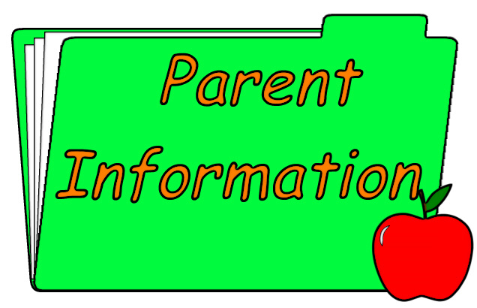

Key Books for the Autumn Term

*You do not need to purchase these – this is just for your information. The reasoning book is listed as parents have asked in the past for additional resources regarding reasoning.*

* Language: ‘Under the Rose’ by Alan Childs.
* Reasoning Textbook ‘Developing numeracy – Using and Applying Maths.’

Maths Times Table Testing

The children will have 2 times table targets each; these will be given for homework to the week before they will be tested.

Reading

In year four the children take part in weekly guided reading sessions, to develop their comprehension and fluency skills. The staged reading books are **not** used for every child, as the focus is on their ability to interpret a text and give their own opinions. This also ensures all the skills used in testing are practiced comprehensively. Staged books and reading groups will be decided when your child starts in year four in September.

Autumn Trips:

Any school trips usually planned for the Autumn term are subject to change due to the Covid 19 situation. We will provide updates on this as soon as possible.

*Possible Summer Holiday Activities*

* Learning Times Tables
* Reading as much as possible
* Researching topics – the autumn term is usually The Tudors