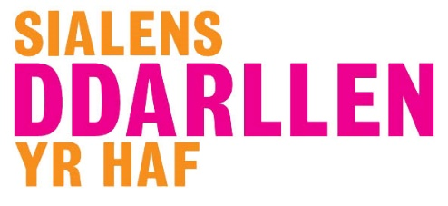
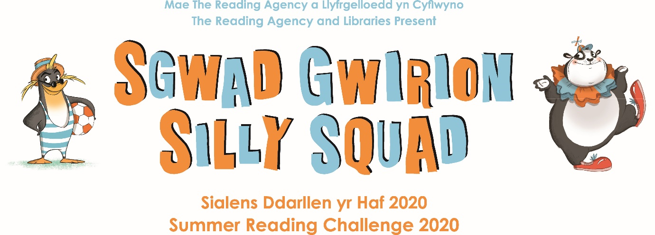

10/07/20

Join our Silly Squad with Aura Libraries
#SillySquad2020 #LetsGetSilly

Take part in this year’s challenge from 17 July
https://summerreadingchallenge.org.uk/

The theme for this year’s Reading Challenge is “Silly Squad” – a celebration of funny books, happiness and laughter, featuring bespoke artwork from award-winning children's author and illustrator, Laura Ellen Anderson.

“I feel the Summer Reading Challenge is extra important this year! How sensible to have a Silly theme. We've all had to deal with serious and scary issues, so it's time for a bit of fun. There are so many comical and crazy children's books to cheer us all up. Let's get reading and get happy!”
- Jacqueline Wilson, Summer Reading Challenge Ambassador

Children can collect their ‘Silly Squad’ Bags from Buckley, Connah’s Quay, Flint, Mold and Mobile Libraries from Monday 27 July. These are full of all the goodies that they will need to complete the challenge from home this year.
Any books can be used- e-books, library books or their own books at home. The aim is to encourage children to read whatever makes them happy, get silly and have fun!

Children can order library books via our ‘Select & Collect’ service by calling 01352 703750, emailing libraries@aura.wales or by filling in an order form via our website www.aura.wales/libraries. Their ‘Silly Squad’ bag will be available to collect with their books.
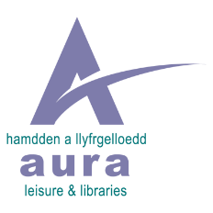
Library Service Manager Susannah Hill said: “We really hope that children across Flintshire want to join our ‘Silly Squad’ and celebrate their reading adventure with us. We really want to encourage them to have fun and read whatever they like over the summer. We hope that the whole family will join in.”

Aura Libraries will offering lots of Silly Squad activities online via Facebook and Zoom that children can join from the comfort of their own home. We are also excited to announce some special activities especially created for us by Theatre Clwyd and Mama G!

A whole host of virtual events and activities will be available via
https://aura.wales/libraries/

www.facebook.com/LlyfrgelloeddAuraLibraries/

https://summerreadingchallenge.org.uk/

The Challenge website will be free to access and a place for children to rate and review their books and work towards their reading goal. It will also feature video content, games, quizzes, and digital and downloadable activities to incentivise and encourage children and their families to take part in the Challenge at home.

****ENDS****
NOTES TO EDITORS:

- The Summer Reading Challenge is the biggest children’s reading for pleasure programme in the UK. Last year over 700,000 children and their families took part.
- The first Summer Reading Challenge took place in 1999 and is an annual initiative with a different theme each year. The programme is delivered by The Reading Agency in partnership with public libraries, publishers and schools.
- The Summer Reading Challenge 2020 will run from July to September.
- The theme for the Summer Reading Challenge 2020 is ‘Silly Squad’. The aim is to encourage children to read whatever makes them happy, get silly and have fun!
- Award-winning children’s book author and illustrator, Laura Ellen Anderson, has created bespoke illustrations for Silly Squad 2020.
- Reading for pleasure is a more important determination of children’s educational success than their families’ socio-economic status. [Sullivan and Brown (2013) Social inequalities in cognitive scores at age 16: The role of reading]
- Studies show that 16-year-olds who read for pleasure outside school are more likely to secure managerial or professional jobs later in life. [Taylor (2011) Reading at 16 linked to better job prospects]
- Statistics show that 1 in 5 children in England cannot read well by the age of 11 [DfE (2015) Reading: the next steps p.13]
- A recent survey commissioned by The Reading Agency showed that 45% of young people are reading more during lockdown.
- It has been proven that children aged 10 who read books often, and more than once a week aged 16, gain higher results in Maths, vocabulary and spelling tests at age 16 than those who read less frequently. [OECD (2010) PISA 2009 Results: Learning to Learn: Student Engagement, Strategies and Practices p. 32-4]

About The Reading Agency:
The Reading Agency is a national charity that tackles life’s big challenges through the proven power of reading. We work closely with partners to develop and deliver programmes for people of all ages and backgrounds; our vision is for a world where everyone is reading their way to a better life. We help 1.8 million people benefit from reading every year, through our programmes, our tireless campaigning, our excellent networks and our power to influence, challenge and make change happen. www.readingagency.org.uk Twitter | Facebook

About Arts Council England:
The Arts Council is the national development agency for creativity and culture. By 2030 we want England to be a country in which the creativity of each of us is valued and given the chance to flourish and where everyone of us has access to a remarkable range of high-quality cultural experiences. Between 2018 and 2022, we will invest £1.45 billion of public money from government and an estimated £860 million from the National Lottery to help deliver this vision. www.artscouncil.org.uk

For local press queries about AURA LIBRARIES
please contact SUSANNAH HILL Susannah.Hill@aura.wales

For further information on The Reading Agency
please contact Saffeya Shebli - saffeya.shebli@readingagency.org.uk.

For logos and images, please click here.

Summerreadingchallenge.org.uk

#SillySquad2020
Illustrations © Laura Ellen Anderson 2020

